Ques: Complete the below task:

1. Explain the below AWS Architecture

2. Implement the same in the AWS(only do a proper connection between service)

NOTE: Submission can be done by sharing the proper screenshots of implementation and doc for explanation!

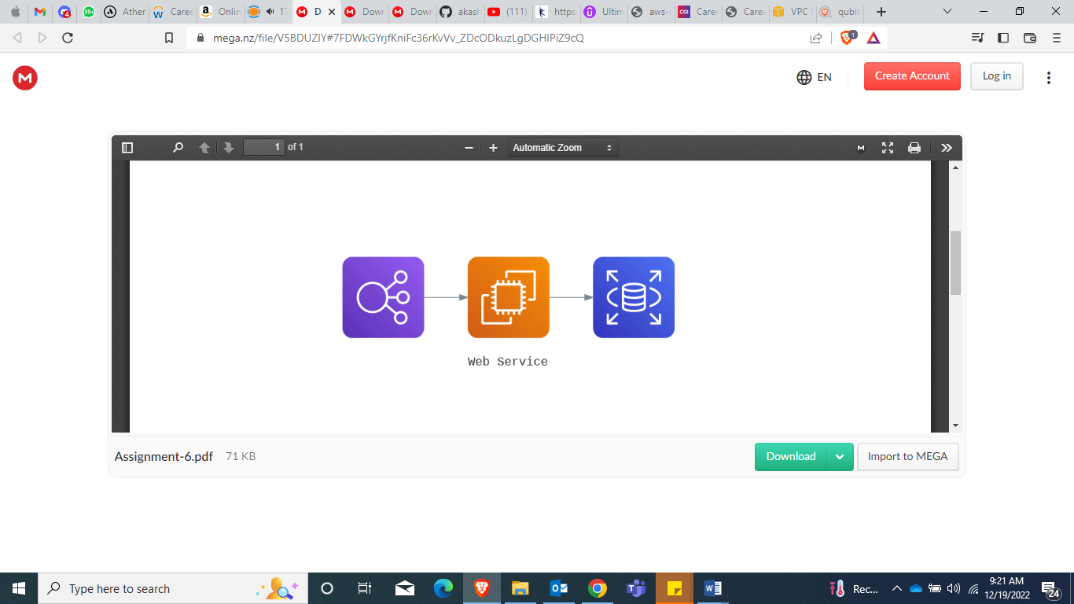

Screenshot of ALB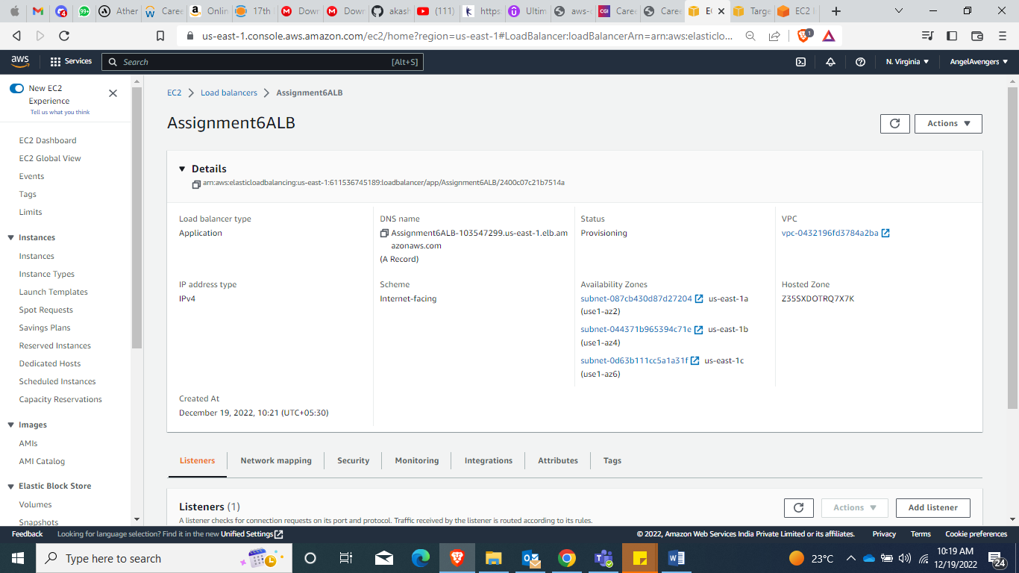

Screenshot for Target Group

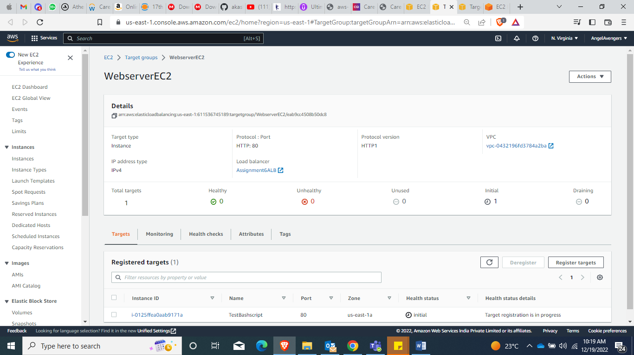

Screenshot attaching EC2 instance over RDS database

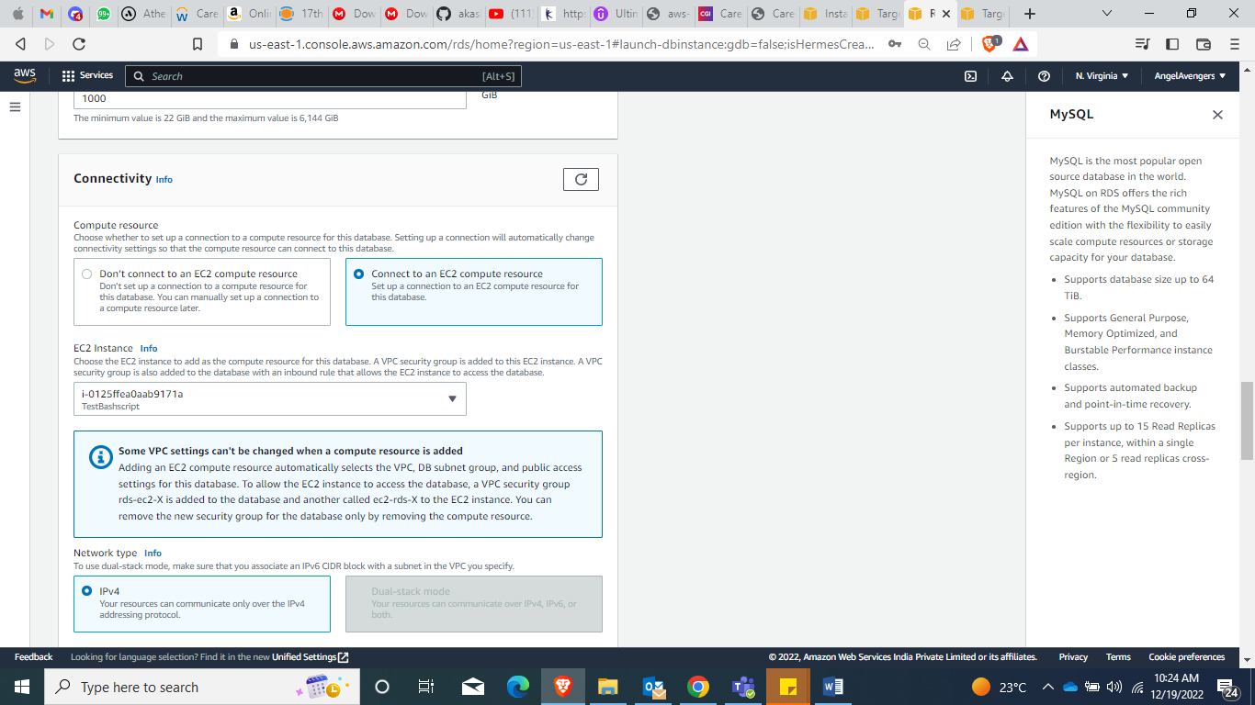

After deploying RDS Database to EC2 instance

